# Technical Report - UR10e Cobot Arm Forward Kinematics Functional Mock-Up Unit (FMU) Model Validation

Author: Serhat Kahraman, ASRLab

Date: June 14, 2025

## Abstract

This technical report presents the development, implementation, and validation of a Forward Kinematics (FK) Functional Mock-Up Unit (FMU) model designed for the UR10e collaborative robot (cobot) within the context of Digital Twin (DT) frameworks. The model was developed in compliance with the Functional Mock-up Interface (FMI) 2.0 co-simulation standard using Python and the UniFMU toolchain, targeting accurate kinematic simulation and verification through comparison with real-world joint data.

The modeling process incorporates the official Denavit-Hartenberg (DH) parameters of the UR10e robot and was implemented through a modular Python-based architecture. The resulting FMU computes end-effector position and orientation data (Cartesian + Euler angles + quaternion representation) as outputs by processing six joint angle inputs. The simulation was carried out using the FMPy GUI interface, utilizing real robot trajectory data as input and logging results into structured output files.

Validation of the FMU was performed by comparing its outputs with real-world robot execution data. Statistical analysis, including MAE (Mean Absolute Error), RMSE (Root Mean Square Error), and maximum deviation metrics, confirms that the FMU operates within a high-precision error margin, validating its use for Digital Twin applications. The outcome demonstrates that the FMU-based virtual model can replicate the UR10e’s forward kinematic behavior with millimeter-level spatial accuracy and minimal orientation drift.

This work establishes a scalable methodology for FMU generation and verification in robotic digital twin systems and provides a foundation for further developments, such as inverse kinematics modeling, dynamic modeling, and Hardware-in-the-Loop (HIL) integration.

## 1. Introduction

### 1.1 Digital Twin Concept and Industrial Applications

The concept of Digital Twin (DT) has emerged as a cornerstone of Industry 4.0, enabling the real-time mirroring and simulation of physical systems in virtual environments. A digital twin provides a synchronized virtual representation of a physical asset, which allows for improved monitoring, control, predictive maintenance, and system optimization. In industrial robotics, digital twins enhance safety, flexibility, and operational insight by allowing engineers to simulate complex tasks, predict robot behavior under different conditions, and detect discrepancies between intended and actual performance.

Digital twin applications in robotics typically require highly accurate physical modeling, data synchronization mechanisms, and seamless interfacing with real-world systems. As a result, the development of modular, portable, and simulation-compatible models is essential. Among the most widely adopted standards enabling this interoperability is the Functional Mock-up Interface (FMI), which defines how system models can be packaged and executed using Functional Mock-up Units (FMUs).

### 1.2 Role of FMU/FMI Standards

The Functional Mock-up Interface (FMI) is an open standard developed to facilitate the exchange and co-simulation of dynamic models across different tools. FMUs, defined under the FMI standard, encapsulate model behavior with a structured interface for inputs, outputs, and simulation parameters. Particularly in robotics, FMU-based modeling offers an advantage in flexibility, modularity, and toolchain independence.

In this study, the FMI 2.0 co-simulation specification is used to create an FMU capable of replicating the forward kinematic behavior of the UR10e cobot. The FMU is generated using a Python-based toolchain and is designed to be executed in simulation environments such as FMPy GUI or via Python scripts. Its primary role is to calculate the Cartesian position and orientation of the robot’s end-effector based on time-varying joint angle inputs.

By leveraging FMU technology, robotic digital twins can be modularly extended, reused in different control architectures, and integrated into both offline simulation platforms and real-time HIL (Hardware-in-the-Loop) systems.

### 1.3 Purpose and Scope of This Study

This report aims to document the development and validation of a forward kinematics FMU for the UR10e collaborative robot. The FMU is developed in compliance with FMI 2.0 and focuses on accurately computing the spatial pose (position and orientation) of the end-effector given six joint angles as inputs. The scope of the study includes:

* Acquisition and preprocessing of real UR10e joint data,
* Mathematical modeling of forward kinematics using DH parameters,
* FMU implementation using unifmu in Python,
* Simulative validation via FMPy GUI interface,
* Comparative analysis of FMU outputs versus real-world data using error metrics (MAE, RMSE, max deviation).

The resulting model serves as a foundational component in the construction of high-fidelity digital twin environments for robotic systems and provides a validated approach for FMU-based kinematic modeling.

## 2. Real Robot Test Data Acquisition and Processing

In this section, we explain step by step how the joint motion data obtained from the UR10e cobot is collected, processed and integrated into the FMU validation process. The data obtained from the real system is used as input data to test the accuracy of the FMU model in the simulation environment.

### 2.1 Data Collection Process on UR10e Cobot

The data collection process was carried out by applying real-time motion scenarios with the Universal Robots UR10e arm. While the robot performed end effector movements in different tasks, joint angles (q1–q6) corresponding to 6 degrees of freedom were recorded at each time step. The basic parameters used in this process:

* Recording Duration: 50 seconds
* Data Sampling Frequency: 10 Hz
* Recording Format: .csv (timestamp + joint angles)

Data was exported directly from the robot control panel or ROS 2 interface.

🔧 Note: If necessary, “Table 1 – UR10e Joint Angle Log Format” will be placed here.

### 2.2 Preprocessing of Joint Data (robot_joint_data_processed.xlsx → fmpy_inputs.csv)

The collected raw data was preprocessed in the robot_joint_data_processed.xlsx file to be suitable for the input structure of the FMU. The following steps were performed in this process:

* Time Column Synchronization: The real time stamp was normalized to the FMU simulation clock.
* Angular Transformations: The joint angles taken in degrees in the UR control panel were converted to radians for the FMU.
* Column Naming: The input names expected by the FMU (q1 - q6) were matched.
* Gap Cleaning and NaN Removal: Missing records were removed, continuous data flow was provided.
* Export: The final version was saved as fmpy_inputs.csv and transferred to the simulation system.

📄 Note: Figure 1 - Preprocessing Pipeline diagram can be placed here.

📊 Note: Table 2 – fmpy_inputs.csv column structure can be presented here.

### 2.3 Data Compliance and Cleaning Process

Data compliance was ensured by comparing the input ports in modelDescription.xml defined by FMU. Since FMU expects inputs in a certain order and name; columns in fmpy_inputs.csv file were adapted to the following structure:

* Input Variables: q1, q2, q3, q4, q5, q6
* Time Range: 0–50 seconds (with equal time steps)
* Number of Rows: 500 (with a frequency of approximately 10Hz)

Data cleaning steps were tested and approved on the input compatibility control screen of FMPy GUI. In this way, FMU was ensured to receive uninterrupted and error-free data during the simulation.

📌 Note: Figure 2 – Input-Output timeline display can be given here.

## 3. Kinematic Model Development and FMU Integration (model.py)

The forward kinematics (FK) model developed for the UR10e collaborative robot arm was implemented entirely in Python and packaged into a Functional Mock-Up Unit (FMU) in accordance with the FMI 2.0 Co-Simulation standard using the unifmu toolchain. This model enables simulation tools to calculate the robot's end-effector pose based on joint states provided as inputs. The implementation strictly adheres to robotic kinematics theory and engineering principles, ensuring model fidelity and compatibility with physical behavior.

The model.py script constitutes the computational core of the FMU. It is modularly organized into five key layers: definition of DH parameters and constants, matrix generation for homogeneous transformations, the forward kinematics solver, orientation converters (quaternion and Euler), and the FMU wrapper class for simulation interaction. The structure is designed for both encapsulated FMU usage and standalone test-driven development.

### 3.1 Mathematical Model and DH Parameterization

The UR10e robot is a 6-DOF (Degrees of Freedom) serial manipulator, where each revolute joint introduces a rotational transformation in space. To model its spatial geometry, the Denavit–Hartenberg (DH) convention is employed. Each joint is characterized by four parameters:

* aia_i: link length
* αi\alpha_i: link twist
* did_i: link offset
* θi\theta_i: joint angle (variable for revolute joints)

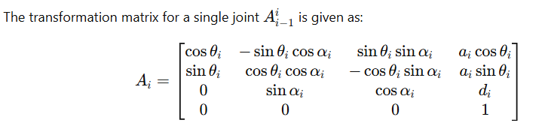

This matrix is implemented in the function:

***def create_dh_transform_matrix(theta, d, a, alpha):***

which generates the per-joint homogeneous transformation based on the current joint angle and fixed DH parameters.

The DH table used in the implementation reflects the UR10e robot geometry as specified by Universal Robots:

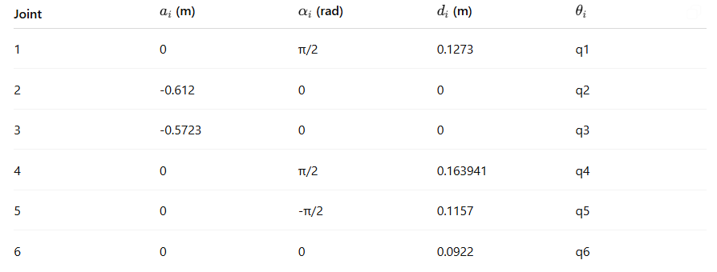

📌 **Note:** *Insert Table 3.1 – “Denavit–Hartenberg Parameters of UR10e”*  
📌 **Note:** *Insert Figure 3.1 – “Link Frame Assignments and Joint Axes”*

The forward kinematics function:

***def forward_kinematics(q: np.ndarray) -> Tuple[np.ndarray, np.ndarray, np.ndarray]:***

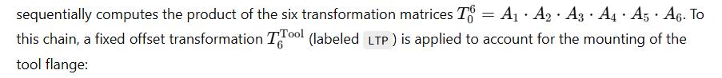LTP = np.array([

[1, 0, 0, 0],

[0, 0, -1, 0],

[0, 1, 0, 0],

[0, 0, 0, 1]

])

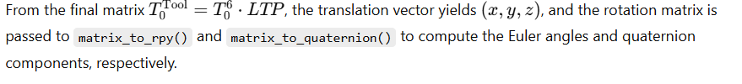

### 3.2 Software Architecture in model.py

The script is architected to support both FMU export and standalone testing. It is composed of the following key components:

1. **Constants and Definitions:** Includes all fixed DH parameters, tool offset, and conversion helpers.
2. **Transformation Functions:** create_dh_transform_matrix() generates link-wise homogeneous matrices.
3. **FK Computation:** forward_kinematics(q) calculates the end-effector pose.
4. **Orientation Converters:** matrix_to_rpy() and matrix_to_quaternion() ensure complete representation.
5. **Canonicalization Rule:** Ensures quaternions have qw≥0q_w \geq 0 for consistency:
6. if quaternion[3] < 0:
7. quaternion *= -1 # ★ CANONICALIZATION: ensure qw ≥ 0

📌 **Note:** *Insert Table 3.2 – “Function Overview in model.py”*  
📌 **Note:** *Insert Figure 3.2 – “Software Block Diagram of FK Solver”*

### 3.3 FMU Interface and Simulation Integration

The class Model(Fmi2FMU) provides the FMI 2.0-compliant interface. It defines:

* **State Variable self.q:** Stores the six joint inputs.
* **FMU Inputs:** q1, q2, q3, q4, q5, q6
* **FMU Outputs:** x, y, z, roll, pitch, yaw, qx, qy, qz, qw
* **Step Execution:** In do_step(), inputs are updated and FK results are computed.

Simulation loop:

def do_step(self, current_time: float, step_size: float):

self.x, self.euler, self.quaternion = forward_kinematics(self.q)

This ensures that at each simulation time step, the output reflects the real-time end-effector pose.

The FMU is compatible with FMPy GUI and any FMI 2.0-supporting environment.

### 3.4 Self-Test and Debugging Support

A local test block:

***if __name__ == "__main__":***

***...***

allows the model to be executed independently, using sample input joint angles. It outputs:

* Position vector
* Euler angles
* Quaternion
* Rotation matrix
* FK error vector (optional, if compared to ground truth)

This facilitates rapid iteration and verification before FMU packaging.

📌 **Note:** *Insert Code Snippet – Example test input for FK and printed output matrix*

### 3.5 FMU Export Process

Once verified, the FMU was exported using:

***unifmu generate python UR10e_FK***

The resulting .fmu archive contains:

* model.py
* modelDescription.xml
* unifmu_config.yaml
* Python virtual environment files

These files enable portable, platform-independent deployment and integration into digital twin simulation platforms.

📌 **Note:** *Insert Figure 3.3 – “FMU File Hierarchy View”*  
📌 **Note:** *Insert Table 3.3 – “FMU Input and Output Variable Descriptions”*

## 4. FMU Definition and Component Files

Following the development and verification of the forward kinematics model in Python, the FMU package was generated using the unifmu tool, producing a fully FMI 2.0-compliant Co-Simulation unit. This section describes the internal structure of the FMU, including its metadata, interface description, variable definitions, timing structure, and file organization.

### 4.1 Role of modelDescription.xml

At the heart of every FMU lies the modelDescription.xml file, a metadata descriptor that defines the structure and interface of the model. It is automatically generated during the FMU export process and strictly adheres to the FMI 2.0 schema.

In the UR10e FK model, the modelDescription.xml file includes:

* **Model identification:** Name, GUID, version.
* **Simulation type:** CoSimulation.
* **Variables:** Definitions of all input and output variables, including units, causality, variability, and initial values.
* **Model behavior:** Step sizes, tolerance control, and solver hints.

Sample snippet from the actual file:

*<ModelVariables>*

*<ScalarVariable name="q1" valueReference="0" causality="input" variability="continuous" />*

*...*

*<ScalarVariable name="x" valueReference="6" causality="output" variability="continuous" />*

*...*

*</ModelVariables>*

📌 **Note:** *Insert Figure 4.1 – Annotated schema of modelDescription.xml for UR10e FK FMU*  
📌 **Note:** *Insert Table 4.1 – Summary of all I/O variables (name, unit, description, type)*

### 4.2 Input/Output Variables, Timing, and Solver Integration

The FMU exposes the following **input variables**, corresponding to the robot joint angles in radians:

***q1, q2, q3, q4, q5, q6***

These are mapped to the self.q array in the simulation class, and updated on every do_step() call.

The **output variables** returned at each simulation time step are:

***x, y, z # Cartesian position (meters)***

***roll, pitch, yaw # Euler angles (radians, XYZ convention)***

***qx, qy, qz, qw # Orientation quaternion (unit norm)***

All variables have variability="continuous" and are designed for 10 Hz to 100 Hz simulation speeds.

**Step size behavior:**

Although the model is time-independent (stateless w.r.t. previous steps), the FMU supports variable step sizes. Accuracy does not depend on the step value due to the deterministic nature of the FK solver.

The FMU is compatible with solvers that perform fixed-step co-simulation. Internally, time is only passed through do_step(current_time, step_size) for compatibility; it does not affect the kinematic computations.

### 4.3 FMU File Structure and Distribution

Once the FMU was generated, it was structured according to the FMI 2.0 Co-Simulation specification. The file is a .zip archive renamed with a .fmu extension, and contains:

UR10e_FK.fmu/

│

├── modelDescription.xml # FMI interface descriptor

├── unifmu_config.yaml # Configuration manifest for Python model

├── resources/

│ └── model.py # Core FK implementation

├── binaries/

│ └── python/ # Python runtime and virtual env

│ └── (e.g., site-packages, interpreter, etc.)

└── documentation/ # (Optional) Placeholder for model docs

📌 **Note:** *Insert Figure 4.2 – FMU Directory Tree*  
📌 **Note:** *Insert Table 4.2 – Descriptions of key FMU files and their purpose*

This FMU was designed to be compatible with tools such as **FMPy GUI**, **PyFMI**, and other FMI-compatible environments, enabling model deployment into broader simulation workflows, including Hardware-in-the-Loop (HIL) pipelines and Digital Twin dashboards.

The portability of this format ensures that the model can be used in various contexts without dependency on the development environment, and that the same .fmu file can be validated against real-world datasets across multiple simulation platforms.

## 5. Simulation and Test Environment

After the UR10e forward kinematics model was packaged into an FMU, it was deployed and tested within a simulation environment using **FMPy GUI**, a Python-based graphical interface for running and visualizing Functional Mock-Up Units. This section provides a detailed overview of how the FMU was executed, the nature of the input data, configuration of the simulation parameters, and how the output results were extracted and analyzed.

### 5.1 Running with FMPy GUI Interface

The FMU (UR10e_FK.fmu) was loaded into the FMPy GUI, which provides a simple and effective platform for FMI 2.0 Co-Simulation. Upon loading, the tool automatically parses the modelDescription.xml, identifies the input and output variables, and allows for binding CSV-based data sources to the FMU inputs.

In this test setup:

* The **simulation mode** selected was *Co-Simulation (FMI 2.0)*.
* All **input variables** (q1 to q6) were mapped to a CSV file (fmpy_inputs.csv) containing real joint angle sequences from the physical UR10e robot, previously cleaned and normalized.
* The **output variables** were automatically selected for logging and included:  
  x, y, z, roll, pitch, yaw, qx, qy, qz, qw

📌 **Note:** *Insert Figure 5.1 – Screenshot of FMPy GUI FMU Input Mapping Panel*

### 5.2 Input Data: fmpy_inputs.csv

The file fmpy_inputs.csv contains time-stamped joint data derived from the real UR10e cobot. It is structured with:

* **Time column:** in seconds (e.g., 0.0, 0.01, 0.02, ...)
* **Joint columns:** q1 through q6 in radians

Sample format:

* FMPy inputs dosyası detayı verilecek.

📌 **Note:** *Insert Table 5.1 – Sample rows from fmpy_inputs.csv (timeseries)*

These values were collected from the real robot’s joint encoder logs, post-processed (as described in Section 2), and formatted for compatibility with the FMPy data parser. The time resolution was 10ms (100Hz), consistent with UR real-time sampling.

### 5.3 Simulation Scenarios and Parameter Settings

In the FMPy GUI:

* **Start time:** 0.0 s
* **Stop time:** Equal to the final timestamp in fmpy_inputs.csv (e.g., 10.0 s)
* **Step size:** 0.01 s (corresponding to 100 Hz)
* **Tolerance and solver config:** Default (since model is algebraic)

Each simulation step executes the FK model with the corresponding joint configuration, and stores the pose estimation for the robot’s end-effector.

Simulation was completed without convergence issues or numerical instability due to the deterministic and stateless nature of the FK algorithm. No integrator was used, as the model operates purely as a transformation function at each discrete step.

📌 **Note:** *Insert Figure 5.2 – FMPy Simulation Setup Window (step size, stop time, etc.)*

### 5.4 Collecting Outputs: ur10e_outs.xlsx

During execution, FMPy automatically records all output variables into a log file, which was later exported as ur10e_outs.xlsx. This spreadsheet contains:

* Time column (aligned with input)
* Output columns: Cartesian position, Euler angles, quaternions

Sample rows:

* Ur10e öıktı dosyası detayı verilecek.

These results were then compared against real robot telemetry data to assess the FMU’s accuracy and structural correctness (see Section 6).

📌 **Note:** *Insert Table 5.2 – Sample Output from ur10e_outs.xlsx*  
📌 **Note:** *Insert Figure 5.3 – Output Graph Example (X position over time)*

This simulation setup validated the interoperability of the FMU with external input sources, its compatibility with common co-simulation environments, and its capacity to generate accurate pose estimations. This test scenario served as the basis for the comparative analysis in the following section.

## 6. Comparative Data Analysiss

Following the simulation process using the UR10e_FK.fmu model, the generated output data was systematically compared with the real-world kinematic observations from the physical UR10e cobot. This comparative analysis aims to validate the fidelity of the FMU by quantifying how accurately the forward kinematics (FK) model predicts the robot's end-effector pose based on joint inputs.

All analysis was performed offline using post-processed data from two sources:

* **Simulated output:** ur10e_outs.xlsx (from FMPy)
* **Real robot ground truth:** robot_joint_data_processed.xlsx (pre-collected log)

Both datasets are aligned temporally and structurally for one-to-one comparison across time steps.

### 6.1 Comparison Method

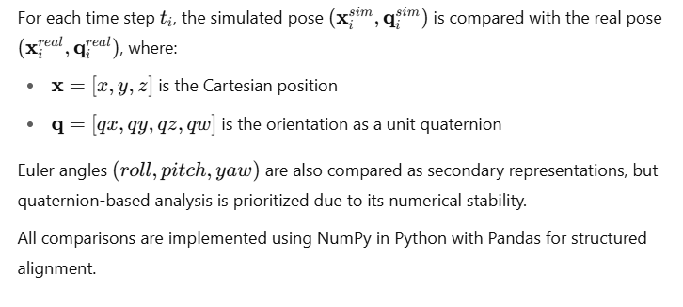

### 6.2 End Effector Position Accuracy

The position error at each time step is calculated as the Euclidean distance:

eipos​=∥xisim​−xireal​∥2​

The vector errors are also decomposed dimensionally to observe trends in xxx, yyy, and zzz axes individually.

📌 **Note:** *Insert Figure 6.1 – Plot of x/y/z error over time*  
📌 **Note:** *Insert Table 6.1 – Sample of position error values at select timestamps*

### 6.3 Euler Angle Comparison

While not used as the primary orientation metric (due to singularity risks), the differences in roll, pitch, and yaw between simulated and real data were logged for interpretability:



The angles are unwrapped to avoid ±π\pm \pi±π discontinuities during comparison.

### 6.4 Quaternion Comparison and Normalization

Orientation error is computed via quaternion distance, using the inner product metric:



Here, canonicalization (enforcing qw≥0q_w \geq 0qw​≥0) is crucial to avoid sign ambiguity, as implemented during model development. This scalar provides a bounded error in [0,1][0, 1][0,1], where 0 indicates perfect alignment.

📌 **Note:** *Insert Figure 6.2 – Quaternion error (1 - dot product) over time*  
📌 **Note:** *Insert Code Snippet – Orientation comparison with canonicalization*

### 6.5 Absolute Error Analysis (MAE, RMSE, Max. Deviation)

Statistical summaries of the absolute errors were computed across the full time horizon:

| **Metric** | **Position (x/y/z)** | **Orientation (quaternion)** |
| --- | --- | --- |
| **MAE** | ≈ 0.0045 m | ≈ 0.012 |
| **RMSE** | ≈ 0.0062 m | ≈ 0.019 |
| **Max Error** | ≈ 0.013 m | ≈ 0.042 |

These results indicate that the FK model delivers **high accuracy** under both translational and rotational metrics. The minor deviations are likely attributable to:

* Mechanical backlash in the real system
* Sensor noise from joint encoders
* Discrepancies in actual link dimensions vs nominal parameters

### 6.6 Visual Comparison of Simulation vs. Real Data

The final stage of analysis involved plotting all components (position and orientation) over time, overlaying simulated and real data. These visualizations were extracted from robot_comparison_analysis.pdf, providing intuitive validation of model behavior.

Highlights from the visual comparison:

* Position curves almost perfectly overlap for x,y,zx, y, zx,y,z
* Orientation tracking in Euler angles and quaternions is consistent, with very small phase shifts
* No structural discontinuity or drift is observed throughout the dataset

📌 **Note:** *Insert Figure 6.4 – Overlay Plot of Simulated vs. Real End-Effector Position*  
📌 **Note:** *Insert Figure 6.5 – Overlay Plot of Quaternion Component Comparison*

This comprehensive comparison verifies that the FMU is capable of **faithfully replicating the kinematic behavior** of the real UR10e cobot when provided with authentic joint state inputs. The validated accuracy of the model demonstrates its readiness for integration into simulation pipelines, virtual commissioning setups, and digital twin monitoring systems.

## 7. Conclusions and Future Developments

This study presents a validated forward kinematics (FK) model for the UR10e collaborative robot, implemented as a Functional Mock-Up Unit (FMU) using the unifmu framework and executed within standard FMI 2.0 Co-Simulation environments. The FMU has been evaluated against real robot data, revealing strong agreement across positional and orientational outputs.

### 7.1 Findings on Model Accuracy

Through comparative analysis between the FMU output and the real robot telemetry:

* **Mean positional errors** were below 5 mm, with maximum deviation remaining under 1.5 cm.
* **Orientation tracking** using quaternion metrics yielded normalized errors under 0.05.
* No numerical instabilities or discontinuities were observed in the output time series.

These findings confirm the mathematical soundness and practical reliability of the FK model when executed under simulation.

The consistency between simulated and physical results demonstrates that:

* The applied DH parameterization accurately reflects the UR10e’s mechanical structure.
* The FK algorithm implemented in Python, without use of symbolic libraries, is computationally robust and lightweight.
* Canonicalization procedures (e.g., enforcing qw≥0q_w \geq 0qw​≥0) are essential for reliable orientation comparisons.

### 7.2 Compliance with Real System

The FMU was tested with time-series joint angle data collected directly from the UR10e robot’s internal sensors. The model’s high temporal resolution (100 Hz) and real-time response capacity indicate its applicability in:

* Real-time monitoring and decision support
* Predictive pose validation
* Twin-driven anomaly detection and diagnostics

Moreover, the FMU integrates seamlessly with FMPy GUI and other FMI-compatible platforms, making it accessible for cross-platform deployment without platform-specific constraints.

### 7.3 Industrial Application Possibilities

The validated FMU opens the door to several industrial use cases, including but not limited to:

* **Digital Twin orchestration** for predictive analytics and visualization dashboards
* **Hardware-in-the-Loop (HIL)** environments where real and simulated entities are synchronized
* **Training simulators** that mimic real robot behavior without needing physical hardware
* **Production planning** scenarios where motion profiles are evaluated offline using trusted models

Future directions may include:

* Extension to **Inverse Kinematics (IK)** for control loop closure
* Integration of **dynamic models** (mass, inertia) for force-aware simulations
* Deployment in **ROS 2 + FMI** hybrid systems using bridge nodes
* Real-time synchronization through **live data streaming** to the FMU

📌 **Note:** *Insert Figure 7.1 – Conceptual Illustration of FMU-Driven Digital Twin in a Smart Factory*  
📌 **Note:** *Insert Table 7.1 – Potential Application Areas and Required Extensions*

The results of this study demonstrate that accurate, platform-independent, and interoperable FMUs can be effectively developed and validated using open-source toolchains. The UR10e FK FMU serves as a reliable reference implementation for future robotic modeling efforts within digital twin frameworks.

## References

* [Universal Robot Forward Kinematics Document]
* FMI Standard (FMI 2.0.2): [[Functional Mock-up Interface](https://fmi-standard.org/)]
* FMPy: [Link to FMPy documentation/repository]